Title of Scientific Presentation
A. B. Author¹, C. D. Collaborator^{1,2}, and E. Researcher²
¹ First University, First City, First Postal Code, First Country
² Second Research Centre, Second City, Second Postal Code, Second Country
The abstracts for EFTC-2019 (http://www.eftc2019.ugent.be/) should be typed using Times New Roman font (12 pt, normal, justified) with single line-spacing, on A4 paper dimensions (210 mm × 297 mm) and leaving a 2.5 cm margin on all sides. The submitted abstracts should be suitable for direct reproduction (i.e. edited as office documents or other desktop publishing products; please do not submit scanned documents), and their length should not exceed one page. It is also kindly requested not to use page numbering.
The abstract should begin with the title (14 pt, bold, centered), followed by the authors’ names (12 pt, normal, centered) and affiliations (12 pt, italic, centered). The name of the presenting author should be underlined, and the authors should be matched with their affiliations via numeric superscripts. Although color pictures will be accepted for the electronic abstract version, please, make sure that your pictures are legible if printed in grayscale. Figure captions should be written in 10 pt italic font. Optionally, numbered references may be included in a separate section at the end of the abstract page (please, follow the examples [1-4] to format this section). Acknowledgements may be included right above the References section, in 11 pt italic font.

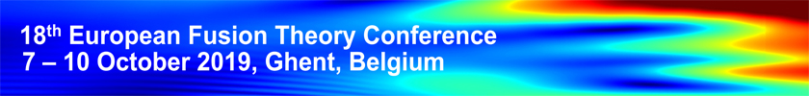
Figure 1: The font of the figure captions should be Times New Roman italic with size 10 pt.

The one-page abstracts, accompanied by the abstract submission form, should be sent by e-mail to eftc2019@ugent.be no later than 30 June 2019. The file format should be one of the following: OpenDocument Text (ODT), Microsoft Word (DOC/DOCX) or Adobe Portable (PDF). A confirmation of receipt of your abstract will be sent to your e-mail within a week from submission. The Scientific Programme Committee will select the contributions on the basis of the submitted abstracts, and the authors will be notified about acceptance of their contribution on July 15, 2019. The authors are requested to follow the conference website http://www.eftc2019.ugent.be/ for useful information and news updates.
This work has been carried out within the framework of the EUROfusion Consortium and has received funding from the Euratom research and training programme 2014-2018 and 2019-2020 under grant agreement No 633053 (EXAMPLE).
References:
[1] A. B. Author, and C. Colleague, Plasma Physics Related Journal 46, 123456 (2019)
[2] E. F. Scientist, et al., arXiv:1794.02198
[3] G. Supervisor, H. Student, et al., Phys. Publications (in press)
[4] I. Physicist, “Experimental results from my research work”, 123th ABCD Fusion Power Conference (Somewhere city, Someplace country), WX/P13-35 (2019)

